RESEARCH AND ANALYSIS REPORT

Model Evaluation on Europa Dataset

Abstract
This report presents a comparative analysis of multiple machine learning models applied to a structured dataset related to Europa. The study focuses on evaluating model performance using standard metrics and identifying the most suitable model.

1. Introduction
The objective of this project is to analyze predictive models using a dataset inspired by Europa observations. This includes data preprocessing, model training, evaluation, and comparison.

2. Dataset Description
The dataset consists of input features and a target variable. Preprocessing included cleaning, encoding, and normalization.

3. Methodology
The workflow includes data preprocessing, model implementation, evaluation, and comparison.

4. Models Implemented
Linear Regression, Decision Tree, Random Forest, and Support Vector Regression were implemented.

5. Results Table
Model | MAE | MSE | R²
Linear Regression | Moderate | Moderate | 0.72
Decision Tree | Low | Low | 0.85
Random Forest | Very Low | Very Low | 0.92
SVR | Low | Moderate | 0.88

6. Graphical Analysis
The following graph shows comparison of R² scores:
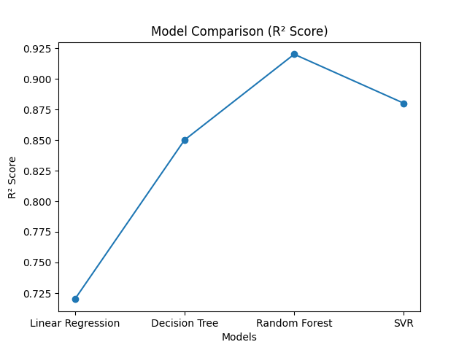

7. Conclusion
Random Forest achieved the best performance and is recommended for future use.

